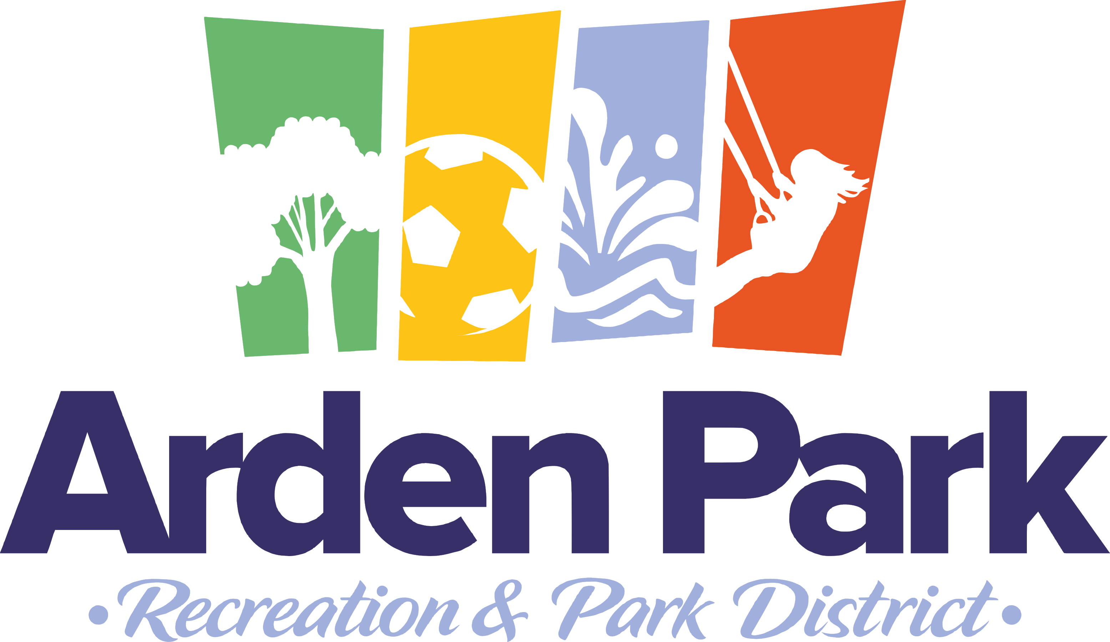

ARDEN PARK RECREATION AND PARK DISTRICT
1000 La Sierra Drive
Sacramento, CA 95864
(916) 483-6069

Board of Directors
Chair, Matt Ross
Richard Heltzel
Bill Andrews
Patrice Wohl
David Burke

Agenda
REGULAR MEETING OF THE BOARD OF DIRECTORS
August 15, 2023
7:00 pm – Arden Park Community Center

This meeting will be held at the above-stated location. This location is accessible to the public, and a member of the public may address the Board of Directors at this location. In compliance with the Americans with Disabilities Act, if you are a disabled person and you need a disability-related modification or accommodation to participate in this meeting, please contact the District office at (916) 483-6069. Requests should be made as early as possible, and preferably at least one full business day in advance of the start of the meeting. Documents and materials related to an open session item on this agenda submitted to this Board after distribution of the agenda packet are available for public inspection and copying at The District office located at the address listed above during normal business hours.

- CALL TO ORDER
    - Welcome
    - Roll Call and Announcement of a Quorum
    - Agenda Approval
- PUBLIC REQUEST TO ADDRESS THE BOARD OF DIRECTORS
    - Any member of the public who requests to address the Board on any item which is not on the agenda may do so at this time. Any matter that requires action by the Board will be referred to the staff for action or staff will be asked to report back to the Board at a subsequent meeting. Comments pertaining to scheduled agenda items will be heard when that item is discussed by the Board. Comments are limited to three minutes per person unless further time is granted by the presiding officer.
- CONSENT AGENDA
    - Approval of the minutes of the Board Meeting held on July 18, 2023
    - Financial Reports-
      - Revenues
      - Salaries
      - General Fund Bills
      - Benefit Assessment Bills
      - Fixed Asset Bills
      - Cash in Treasury
      - Security Reports
- OLD BUSINESS
    - Review and comment on a proposed banner policy
- NEW BUSINESS
    - Closed Session (Pursuant to Government Code 54957)- Confidential Labor Discussion
- REPORTS
    - Staff Report
- BOARD COMMENTS
- ADJOURN

